**Making Connections with oracle in php:**

At first unlock the database schema of the oracle using sql plus. Don’t worry! You have done it in the sessional using the command “alter user hr indentified by hr account unlock;” for the schema hr.

(I am discussing for XAMPP. The procedure is almost same for WAMP or others.)

Open C:/xampp/php/php.ini

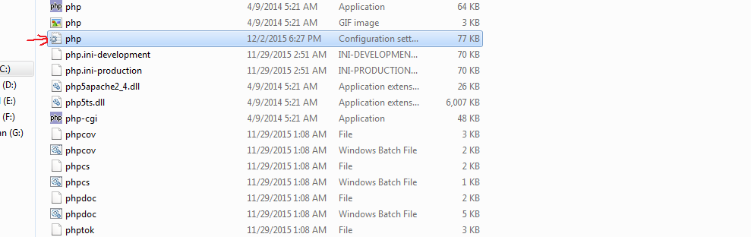

Search the file using the work ‘extension’. You will find the lines as following

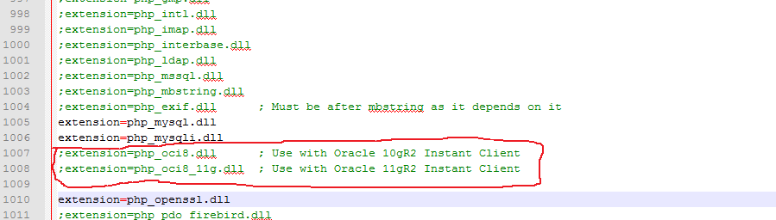

Remove the semicolons.

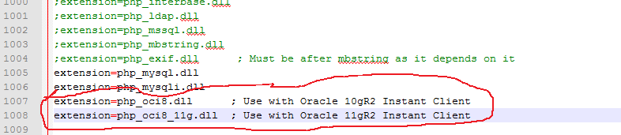

Then you must have to restart the XAMPP to get the effect.

If still there is a problem specially version problem. Then take a zipped folder from me (win32_11gR2_database) . Or you may download it from internet.

Extract the zipped folder.

You will find a folder named “instantclient_11_2”. Extract it anywhere and introduce it in path variable. If you extract it in C drive then the path would be “C:\instantclient_11_2”.

How to find path variable? Control Panel->System and Security->System-> Advanced system settings-> Environment variables->path

